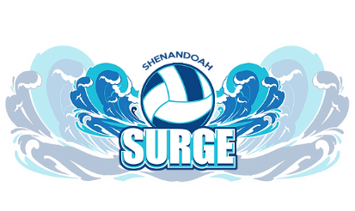

**2024-2025 SEASON LIABILITY WAVER & RELEASE**

The Shenandoah Surge Volleyball Club, LLC (SSVBC) is committed to conducting its open gym and tryouts in a safe manner and holds the safety of participants in high regard. SSVBC continually strives to reduce such risks and insists that all participants follow safety rules and instructions.

However, participants and parents/guardians of minors must recognize that there is an inherent risk of injury when choosing to participate in athletic activities/programs. You are solely responsible for determining if you or your minor child/ward are physically fit and/or adequately skilled for the activities contemplated by this agreement. It is always advisable, especially if the participant is disabled in any way or recently suffered an illness, injury or impairment, to consult a physician before undertaking any physical activity.

**WAIVER AND RELEASE OF ALL CLAIMS AND ASSUMPTION OF RISK**

Please read this form carefully and be aware that in signing, you will be expressly assuming the risk and legal liability and waiving and releasing all claims for injuries, damages or loss which you or your minor child/ward might sustain as a result of participating in any and all activities connected with and associated with this program/activity.

I recognize and acknowledge that there are certain risks of physical injury to participants in this program/activity, and I voluntarily agree to assume the full risk of any and all injuries, damages or loss, regardless of severity, that my minor child/ward or I may sustain as a result of said participation. I further agree to waive and relinquish all claims I or my minor child/ward may have (or accrue to me or my child/ward) as a result of participating in this program/activity against the SSVCB, including its officials, agents, volunteers and employees (hereinafter collectively referred as SSVCB).

I do hereby fully release and forever discharge the SSVCB and their coaches from any and all claims for injuries, damages, or loss that my minor child/ward or I may have or which may accrue to me or my minor child/ward and arising out of, connected with, or in any way associated with this program/activity. By signing below, I consent that I have read and fully understand, and agree to the above important information, warning of risk, assumption of risk and waiver and release of all claims.

Dates of Event: October 2024-July 2025

Print child’s name: _______________________________________________

Print Parent/Guardian’s name: ________________________________________

Parent/Guardian’s Signature: _________________________________________

CHRVA # __________________________________ EXP Date__________________